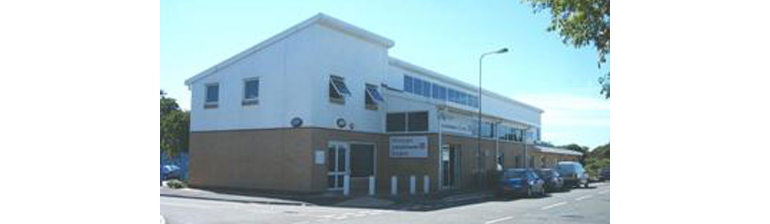
Meddygfa Lansdowne Surgery

TRAVEL RISK ASSESSMENT FORM

Please complete this form prior to your travel appointment and return to reception.
Personal Details

Name:
Address:

Date of birth: |  |  |  |  | Male [ ] Female [ ]
Easiest contact telephone number:
Email:
Dates of trip
Date of departure:
Return date or overall length of trip:
Itinerary and purpose of visit
Country to be visited |  | Length of stay |  | Away from medical help at destination?  If so, how remote?
1.
2.
3.
Please circle the descriptions that best describe your trip

1 Type of trip | Business |  | Pleasure |  |  | Other
2 Holiday type | Packaging |  | Self-organised |  |  | Backpacking
 | Camping |  | Cruise ship |  |  | Trekking
3 Accommodation | Hotel |  | Relatives/family home |  |  | Other
4 Travelling | Alone |  | With family/friend |  |  | In a group
5 Staying in area which is | Urban |  | Rural |  |  | Altitude
6 Planned visits | Safari |  | Adventure |  |  | Other
Personal medical history
Do you have any recent or past medical history of note? This includes diabetes, heart or lung conditions, thymus disorder.
List any current repeat medications.
Do you have any allergies for example eggs, antibiotics, nuts?

Have you ever had a serious reaction to a vaccine given to you before?
Do you or any close family members have epilepsy?
Do you have any history or mental illness including depression or anxiety?
Have you recently undergone radiotherapy, chemotherapy or steroid treatment?
Women only: Are you pregnant or planning pregnancy or breast feeding?
Have you taken out travel insurance? If you have a medical condition, have you informed the insurance company about this?
Please give any further information that may be relevant, including any further travel plans.
Vaccination history
Have you ever had any of the following vaccination/malaria tablets, and if so when?
Tetanus [ ] | Polio [ ] |  | Diphtheria [ ]
Typhoid [ ] | Hepatitis A [ ] |  | Hepatitis B [ ]
Meningitis [ ] | Yellow Fever [ ] |  | Influenza [ ]
Rabies [ ] | Jap B Enceph [ ] |  | Tick Bourne [ ]
Malaria tablets [ ] | Other: Please give details
For discussion when risk assessment is performed within your appointment:
I have no reason to think that I might be pregnant. I have received information on the risks and benefits of the vaccines recommended and have had the opportunity to ask questions. I consent to the vaccines being given.
Signed:................................................ Date......................................

FOR OFFICIAL USE: PRACTICE STAFF ONLY
Appointment Date:.....................................Appointment Time........................................

Travel risk assessment performed |  | YES [ ] |  | NO [ ]
Travel vaccines recommended for this trip

Disease protection | Yes |  | No |  | Further information
Hepatitis A
Hepatitis B
Typhoid
Cholera
Tetanus
Diphtheria
Polio
Meningitis ACWY
Yellow Fever
Rabies
Japanese B Enceph
Other
Vaccines required YES / NO

COST FOR PATIENT: £ ......................
Travel advice and leaflets given as per travel protocol

Food water and personal hygiene advice |  | Travellers’ diarrhoea |  | Hepatitis B, C and HIV |  | Air travel
Insect bite protection |  | Animal bites |  | Accidents |  | Insurance
Sun and heat protection |  | Hajj travel |  | Travel record card supplied |  | Websites
Other :

Malaria prevention advice and malaria chemoprophylaxis

Chloroquine and proguanil |  | Mefloquine |  | Atovaquone and proguanil (Malarone) |  | Doxycycline
Malaria leaflet given |  | Chloroquine

Further information
e.g. weight of child

Signed by:

Position:

Date:

